Practical 14: Sales Data Workbook
Aim
To analyze sales data using Excel formulas and charts.

Objectives
•To use SUMIF formulas
•To filter categories

Materials Required
•Excel

Procedure
1. Enter or import sales data
Add sales records manually or import them from an external file to build your dataset.
2. Sort and filter
Organize the data by sorting and apply filters to focus on specific products, dates, or regions.
3. Use SUMIF
Apply the SUMIF function to total sales based on a chosen condition, such as product type or salesperson.
4. Extract text using LEFT/RIGHT
Use LEFT or RIGHT functions to pull specific characters from product codes or IDs.
5. Create line chart
Plot a line chart to visualize sales trends over time for clearer analysis.
6. Protect sheet
Lock the sheet or specific cells to prevent unauthorized edits and maintain data integrity.

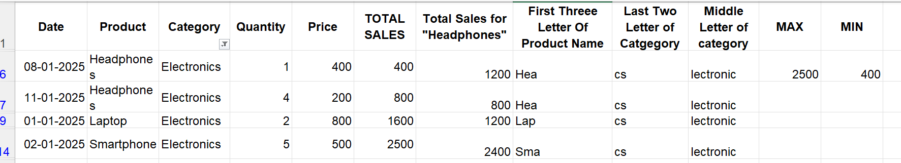
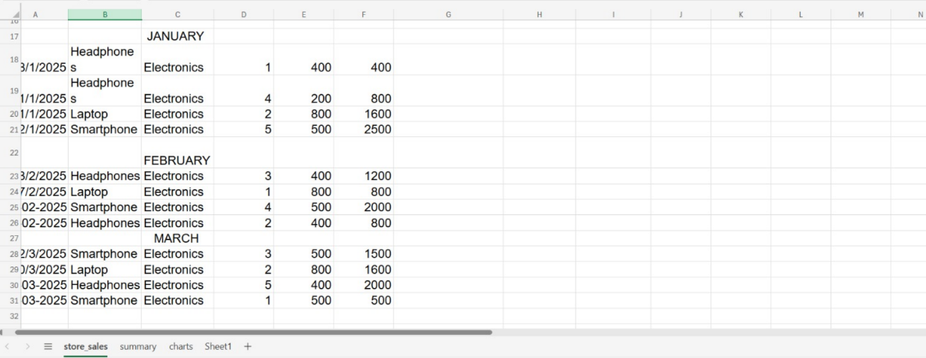
Output:
